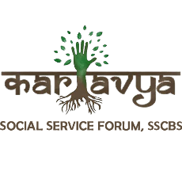
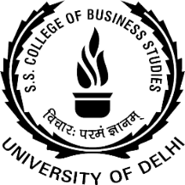
REPORT ON PROJECT SAKSHAM SEMINAR: UNLOCKING THE POWER OF YOUTH FOR CAREER SUCCESS

Date: April 17, 2023
Time: 12:30 PM
Venue: 5th Floor Seminar Hall, SSCBS, DU
Project Saksham, a collaborative effort by Kartavya, the Social Service Forum, and NSS Unit of SSCBS, hosted an engaging and informative seminar aimed at empowering young individuals to achieve their career goals. The seminar addressed various crucial aspects, including identifying the best internships, understanding the impact of college societies, securing the right placements, and implementing effective strategies for professional success.
The event commenced with an enthusiastic introduction by the organizers, emphasizing the importance of youth in shaping the future. The audience, comprising students, aspiring entrepreneurs, and career-oriented individuals, eagerly awaited the insights from the esteemed speaker, Ms. Riya Ahuja.
Ms. Riya Ahuja, a highly accomplished individual, captivated the audience with her remarkable journey. As the Co-founder of FinOak, a final year Economics student at St. Stephen's College, a True North Scholar at Bain & Co., and an upcoming Management Trainee at Unilever, she personified success and expertise.
Ms. Ahuja provided valuable guidance on selecting internships aligned with career aspirations. Practical steps and effective approaches to secure internships with prestigious organizations were discussed, inspiring attendees to proactively pursue valuable learning experiences.
The significance of active participation in college societies was emphasized. Ms. Ahuja highlighted how such engagements foster essential skills like leadership, teamwork, and networking, contributing to a well-rounded resume.
Insights into excelling in the placement process were shared, covering resume building, interview techniques, and presenting oneself confidently. Attendees gained valuable tips to stand out in the competitive job market.
Drawing from her personal triumphs, Ms. Ahuja advised on time management, balancing academics with personal growth, and consistently honing skills, all crucial for a successful professional life.
The Project Saksham seminar proved to be an empowering and inspiring event. Ms. Riya Ahuja's expertise and real-world scenarios left a lasting impact on the audience. Attendees left the seminar motivated and equipped with practical knowledge to unlock their potential and propel themselves towards success.

